**EXPERIMENT 5**

**Aim :**

Write a Program to Perform Addition of 2 Strings in 8086 Microprocessor.

**Requirements :**

8086 Emulator Software.

**Procedure :**

1. Open 8086 Emulator, click on new and select BIN template.
2. Write the code in assembler window.
3. After writing the code in window, click on the emulate button.
4. Check for errors and fix them.
5. If the code is correct, emulator window will popup where we have to input values at defined locations.
6. Input the values using extended value viewer and click on the run button.
7. Observe the result of addition at defined location.

**Program to Add 2 Strings :**

|  |  |  |  |
| --- | --- | --- | --- |
| **Address** | **Mnemonics** | **Operands** | **Comments** |
| 0000H | CLC |  | Clear Carry Flag that is CF = 0 |
| 0001H | MOV CX | 0004H | Move 0004H to CX (Counter) |
| 0004H | MOV SI | 1300H | Move the value from 1300H to SI |
| 0007H | MOV DI | 130AH | Move the value from 130AH to DI |
| 000AH | AHEAD **|** MOV AX , [SI] |  | Give effective address of SI to AX |
| 000CH | ADC [DI] , AX |  | Perform Addition with Carry |
| 000EH | INC SI |  | Increment SI register by 1 |
| 000FH | INC SI |  | Increment SI register by 1 |
| 0010H | INC DI |  | Increment DI register by 1 |
| 0011H | INC DI |  | Increment DI register by 1 |
| 0012H | DEC CX |  | Decrement CX by 1 (Counter) |
| 0013H | JNZ AHEAD |  | Jump to AHEAD (000AH) if ZF = 0 |
| 0015H | HLT |  | End of program |

**Screenshots :**

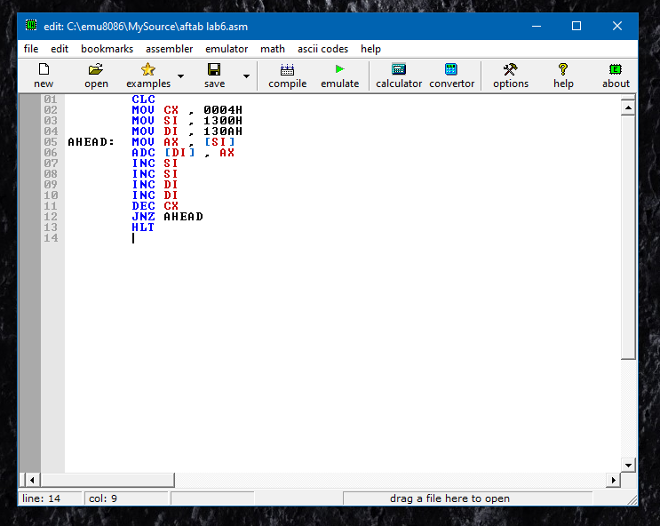

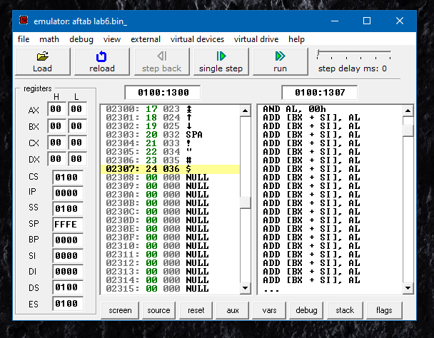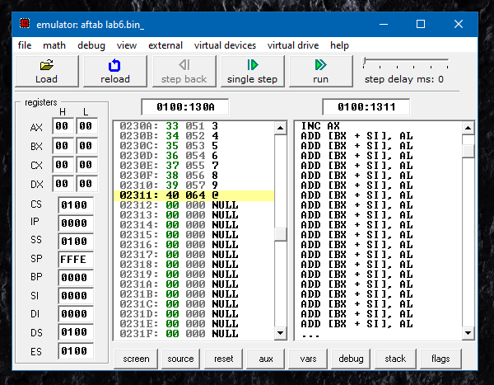

**Flow Chart :**

**No**

**Yes**

**Output :**

|  |  |  |  |  |  |  |  |  |  |
| --- | --- | --- | --- | --- | --- | --- | --- | --- | --- |
| **Before Execution** | **String 1 : SI (1300H)** | **17** | **18** | **19** | **20** | **21** | **22** | **23** | **24** |
| **Before Execution** | **String 2 : DI (130AH)** | **33** | **34** | **35** | **36** | **37** | **38** | **39** | **40** |
| **After Execution** | **Addition Result (130AH)** | **4A** | **4C** | **4E** | **56** | **58** | **5A** | **5C** | **64** |

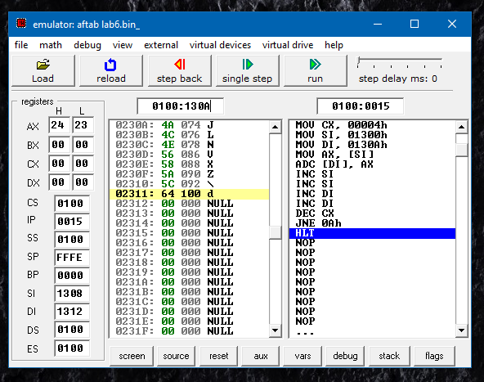

**Result :**

**No**

**Yes**

Program to Add 2 Strings in 8086 Microprocessor was implemented successfully.